Earth Day – Emma Love Hardee Elementary and Southside Elementary
Post-Event News Release

Contact: | Lynda Bell, Executive Director Keep Nassau Beautiful  904-261-0165  knb@keepnassaubeautiful.org

For Immediate Release

More than 1,300 Fernandina Beach students participate in Earth Day Education and Beautification Events

Keep Nassau Beautiful Leads Events at Emma Love Hardee Elementary and Southside Elementary on Earth Day

Fernandina Beach, Florida, April 22, 2019 – Earth Day is a global event which is celebrated each year on 22nd April. This is an event where people come together to show their support for the sake of environmental awareness and protection. More than 1 billion people now participate in Earth Day activities each year, making it the largest civic observance in the world. Keep Nassau Beautiful coordinated two events in Fernandina Beach schools in recognition of Earth Day; the first at Emma Love Hardee Elementary, and later in the day at Southside Elementary.

Emma Love Hardee Elementary Assistant Principal, Bryce Cubbal, scheduled assemblies for more than 600 third, fourth and fifth grade students to participate in a Keep Nassau Beautiful educational event on the 4 R’s; refuse, reduce, reuse, recycle. Ashley Powell, KNB board member, led the interactive educational event where students learned about recycling and the impact of single use plastic. Student volunteers were asked to identify items for recycling and during the process learned the “Do’s and Don’ts” of recycling to avoid contamination of the recycle bin.

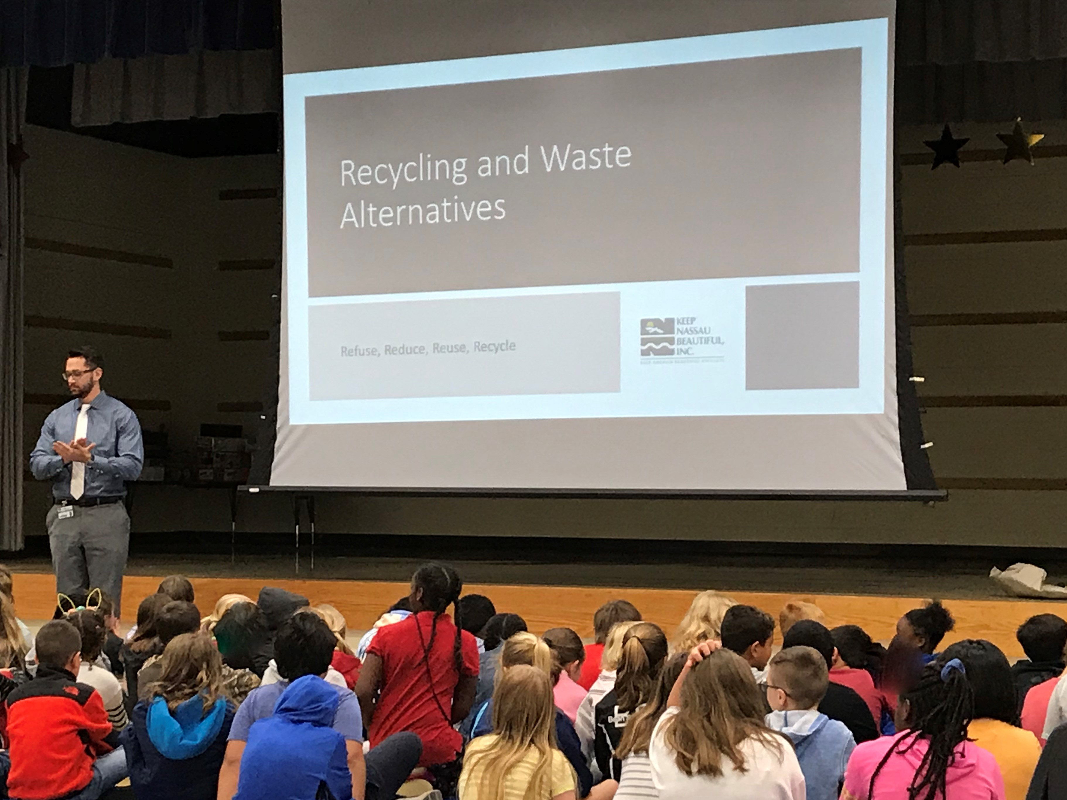
Emma Love Hardee Elementary Assistant Principal, Bryce Cubbal, introduces Keep Nassau Beautiful for an educational program on Recycling and Waste Alternatives.

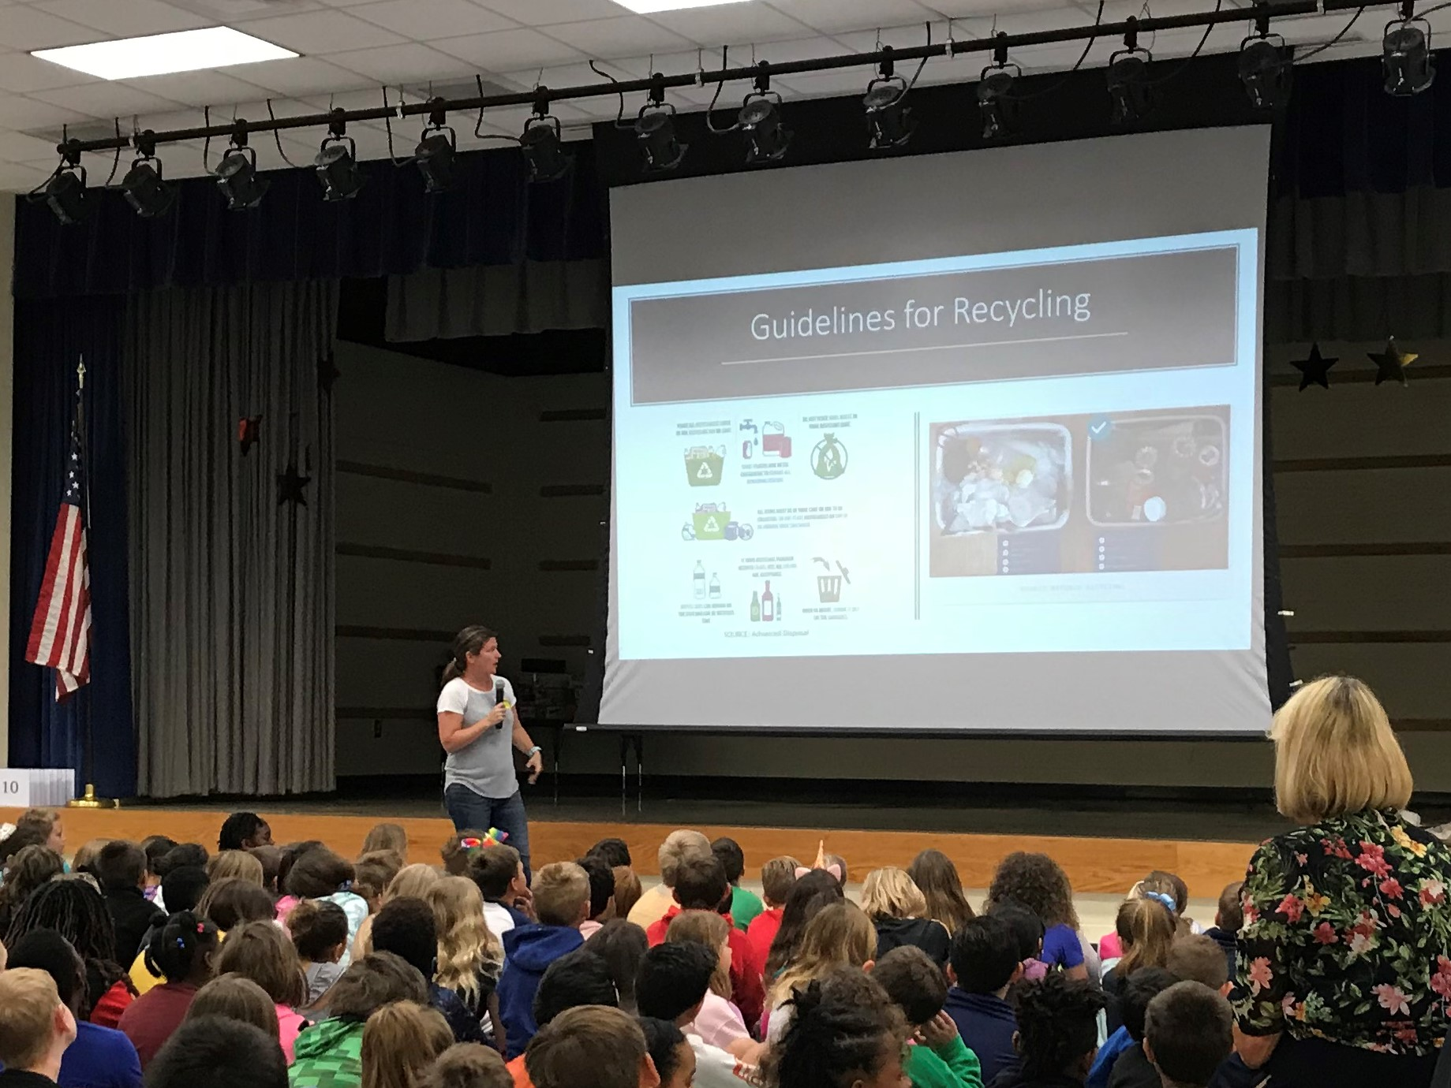
Keep Nassau Beautiful board member, Ashley Powell, leads a student discussion on Do’s and Don’ts of Recycling.

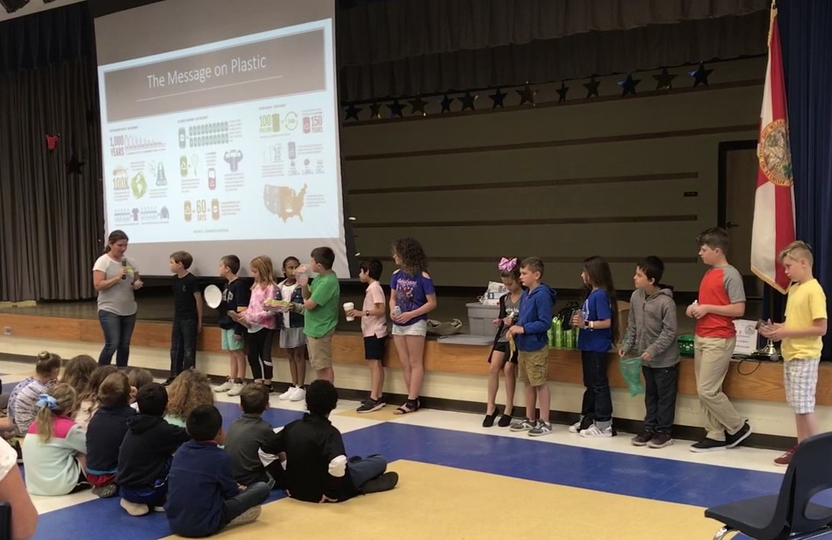
Student volunteers identify items that should be included in the recycle bin.

Southside Elementary Principal, Marlene Palmer, coordinated with Keep Nassau Beautiful for an Earth Day event for just under 700 students in grades K – 2. The Amelia Island Newcomers Club, Garden Group joined KNB to assist teachers and students in transplanting strawberries and tomato plants into take home pots.

Liberty Landscape Supply helped make the Earth Day project possible through their generous donation of plants and potting soil. Digital Village donated paper which was used for drop cloths. And Lowe’s, Fernandina Beach assisted with the supply of terra cotta pots.

Students were able to enjoy transplanting their own fruit or vegetable plant and then taking it home to grow over the summer and later harvest for strawberries or tomatoes.

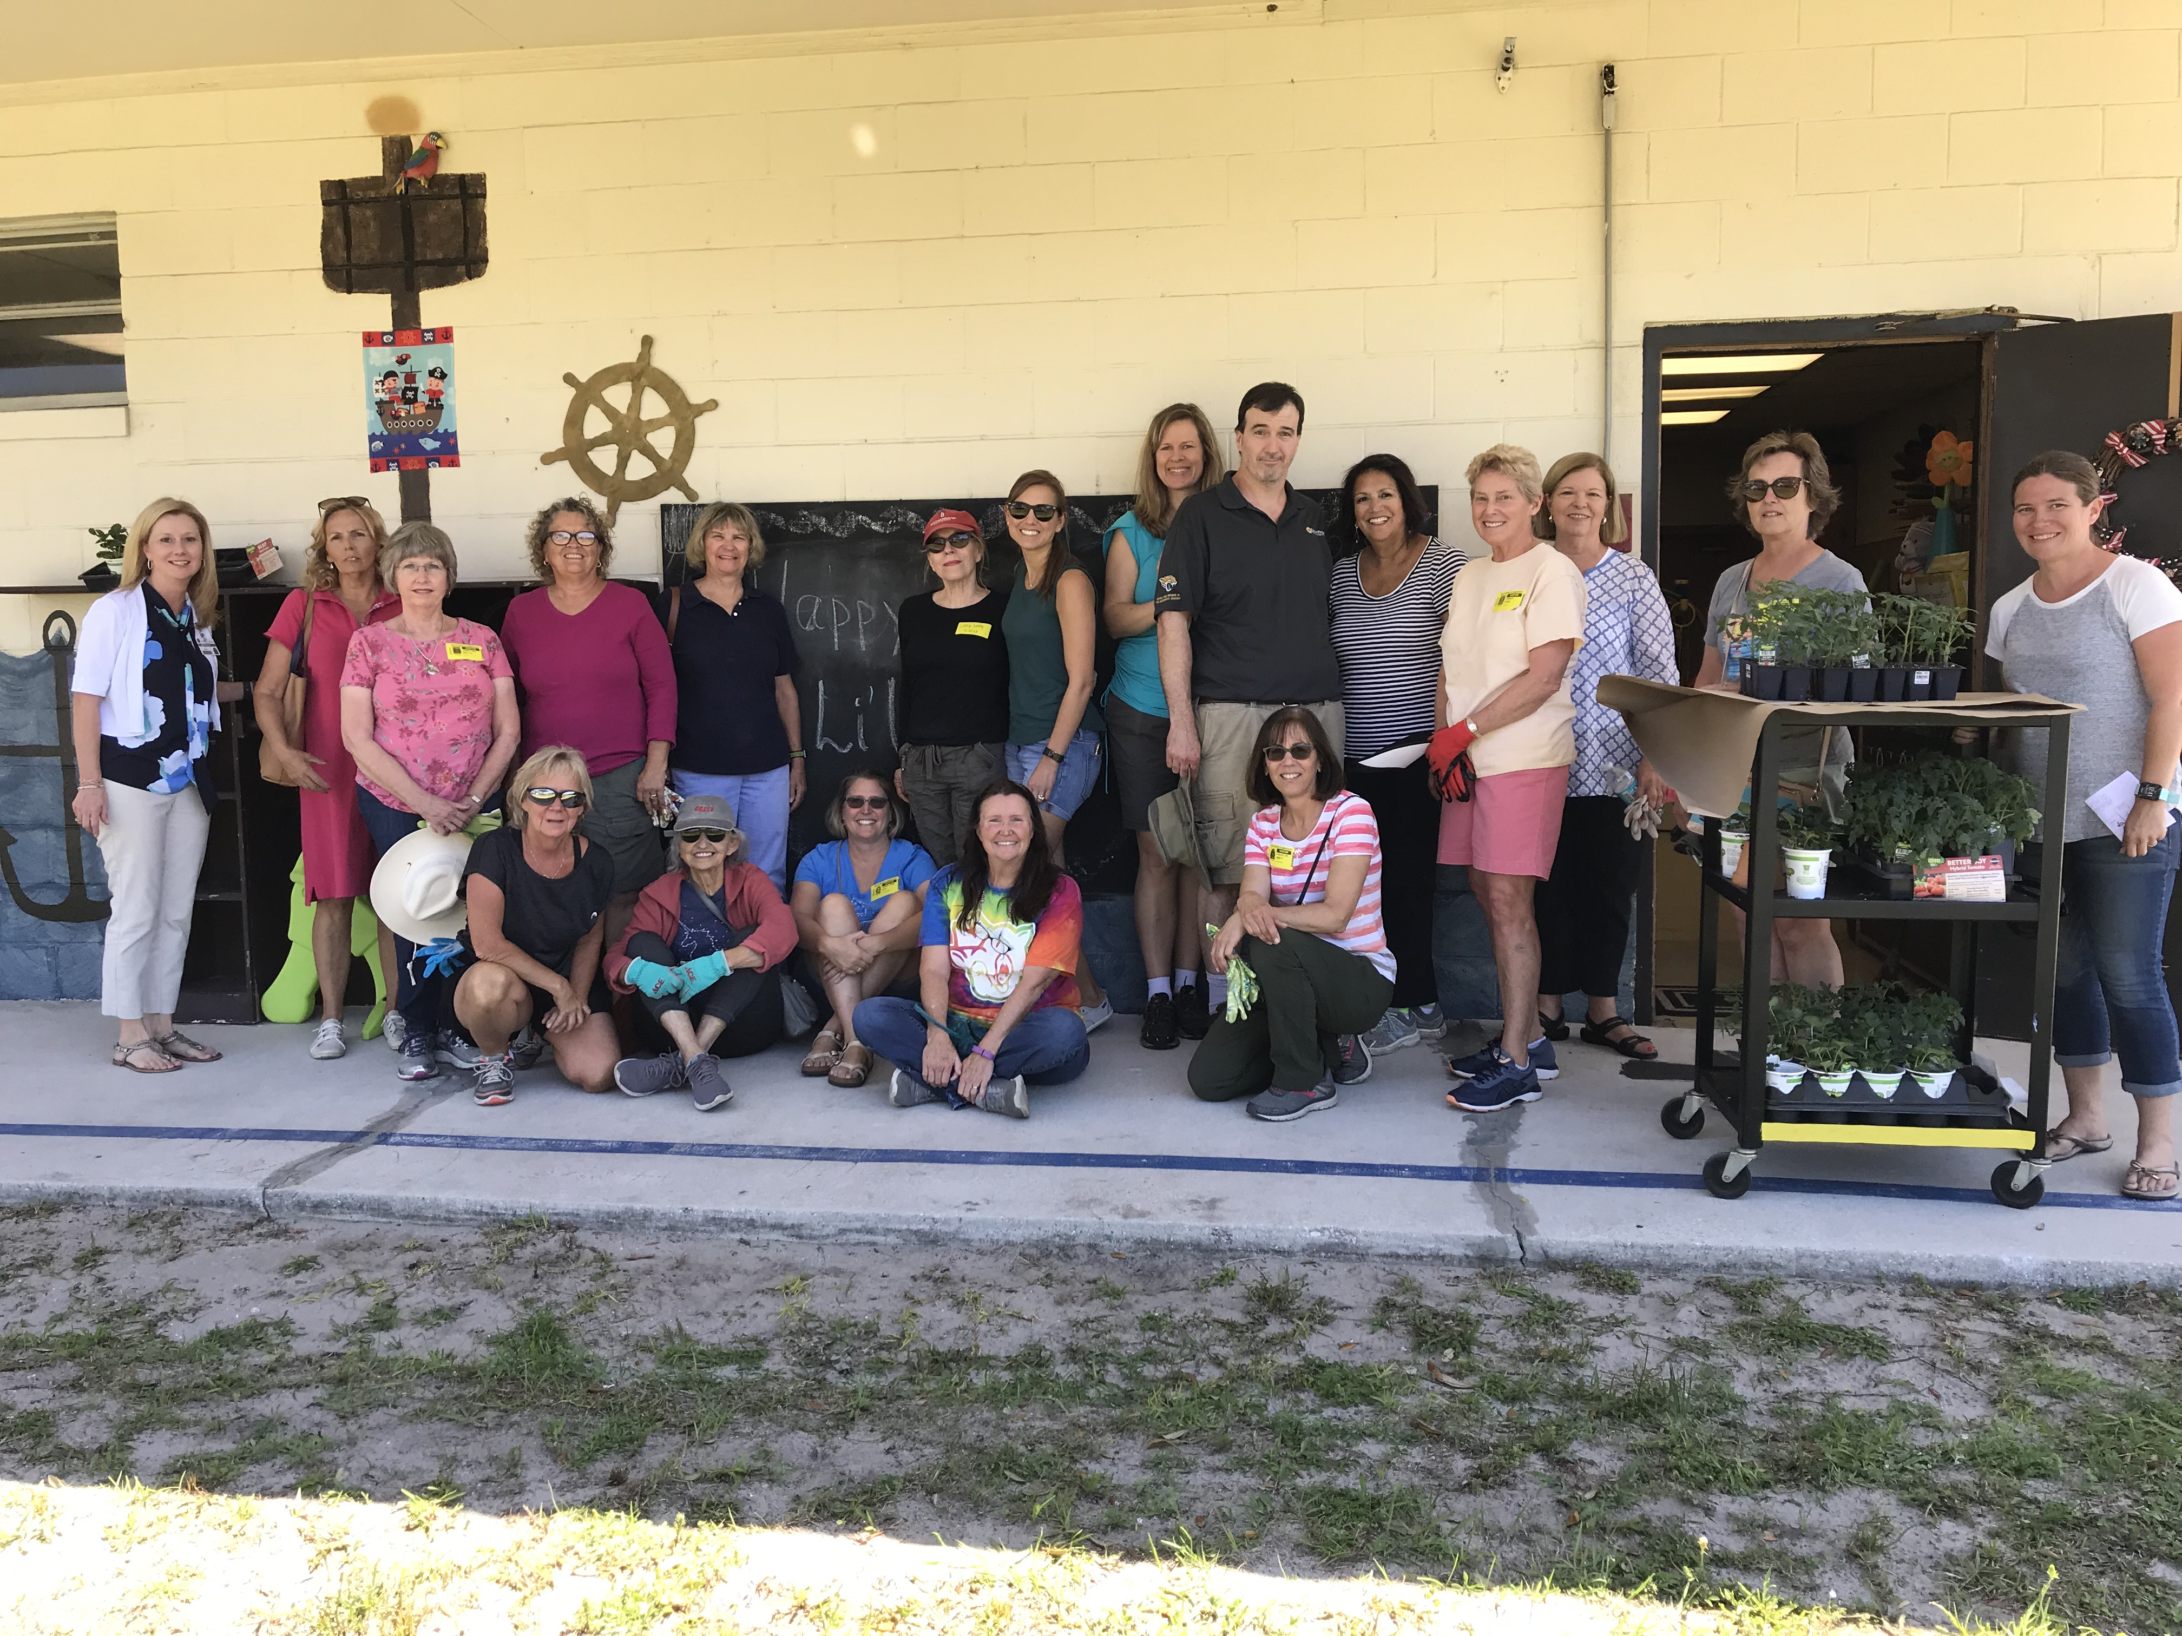
Principal Marlene Palmer, KNB Board Members and Amelia Island Newcomers Club, Garden Group volunteers assist teachers and students in planting project for Earth Day.

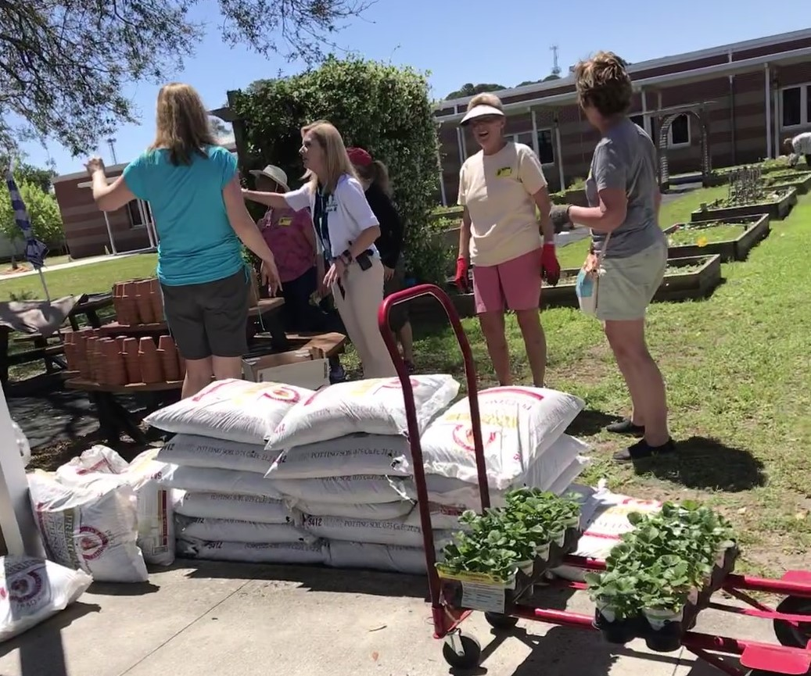
Principal Marlene Palmer and volunteers from Keep Nassau Beautiful and Amelia Island Newcomers Club, Garden Group are staging supplies for Earth Day planting project.

“Earth Day is a chance to consider how your actions impact the planet and think about what steps you can take to help make our environment better,” said Lynda Bell, Keep Nassau Beautiful Executive Director, “which is why we are so grateful to the administration and teachers for raising awareness about environmental issues through Earth Day events. It is great to see students think about how they can reduce pollution, impact recycling, and enjoy tending a plant.”

###

Keep Nassau Beautiful, Inc. is working to inspire, educate, and equip individuals, groups, businesses and governments to take action to make Nassau County a place where residents, visitors and wildlife can thrive and experience the beauty of Nassau County. www.keepnassaubeautiful.org

